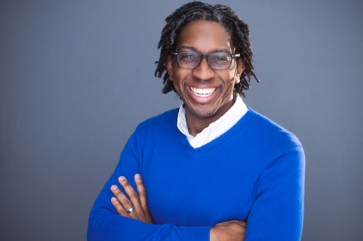

Phone 281.615.0205 • E-mail Aaronbrowndirecting@gmail.com
Directing Experience
Fiddler on the Roof | Harnick & Bock | A.D. Players (2024)
Fairview | Jackie Sibblies Drury | 4th Fall Theatre (2023)
Shakespeare in Love | Lee Hall | University of Houston (2023)
Houston for the Holidays with DeQuina Moore | DeQuina Moore | Stages Theatre (2022)
Beast and Cakes (Staged Reading) | B.V. Marshall | Metzler New Works Festival
You’re Cordially Invited to Sit-In | ShaWanna Renee Rivon | Stages Theatre
Detroit ‘67 | Dominique Morisseau | Sam Houston State University
Once on this Island | Ahrens & Flaherty | Sam Houston State University
Violet | Tesori & Crawley | Sam Houston State University
Golden Boy⁺ | Odets & Strouse | WaterTower Theatre
Godspell | Tebelak & Schwartz | WaterTower Theatre
Crazy for You | Gershwin & Ludwig | Baylor University
Black Magic: A Shakespeare Adaptation | A. Brown | Baylor University
Hairspray | Shaiman & Wittman | Waco Civic Theatre
Hamoncé: A Devised Piece | Company | Baylor University
The Pavilion | Craig Wright | Baylor University
Big Red Sun: A New Musical | Georgia Stitt & John Jiler | OCUStripped New Musical Festival
A Dog’s Life: A New Musical | Sean Grennan & Leah Okimoto | OCUStripped New Musical Festival
Assistant Directing/Observership* Experience
⁺Covid Cancellation
Dear Jack, Dear Louise | Dir. Kevin Dean | A.D. Players
Bread (Regina Taylor, World Premiere) | Dir. Leah Garnier | WaterTower Theatre
Noises Off | Dir. Stan Denman | Baylor University
Astoria Pt. 2* | Dir. Chris Coleman | Portland Center Stage
Mary Stuart* | Dir. David Jortner | Baylor University
Most Happy Fella | Dir. David Herendeen | Oklahoma City University

Education and Theatrical Experiences
Texas State University Assistant Professor and Co-Head of Musical Theatre (Currently)
Sam Houston State University Assistant Professor and Co-Head of Musical Theatre (2019-2023)
Baylor University, MFA in Theatre Directing, 2018
Oklahoma City University, BM in Musical Theatre, 2009
Theatrical Intimacy Education: Educator Advocate Program, 2022
Detour: New Play Festival, Literary Reader, WaterTower Theatre, 2018
Producer/Director for OCUStripped, 2007-2009
Artistic Intern, Ensemble Theatre (Houston), 2007
www.aaronbrowndirecting.squarespace.com/
References available upon request

